Q. Create a VNET with multiple subnets for different purposes, i.e, frontend, backend and private.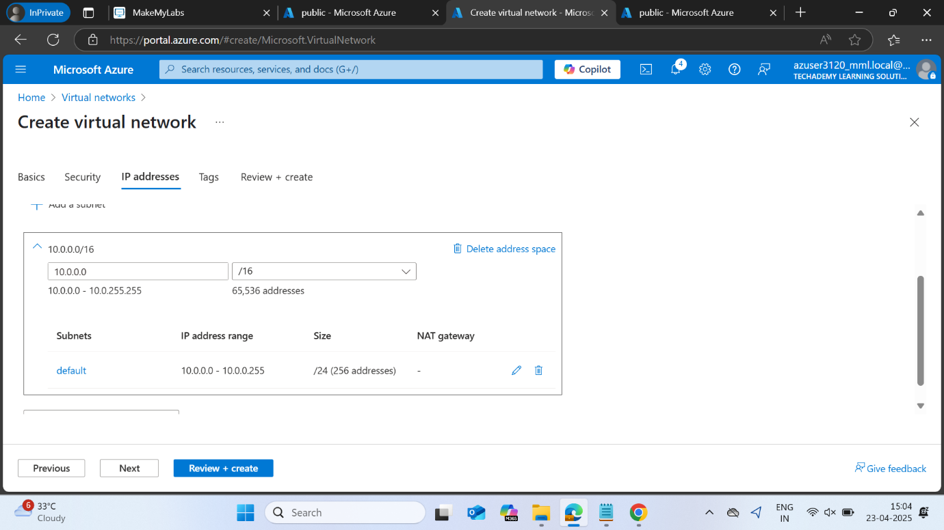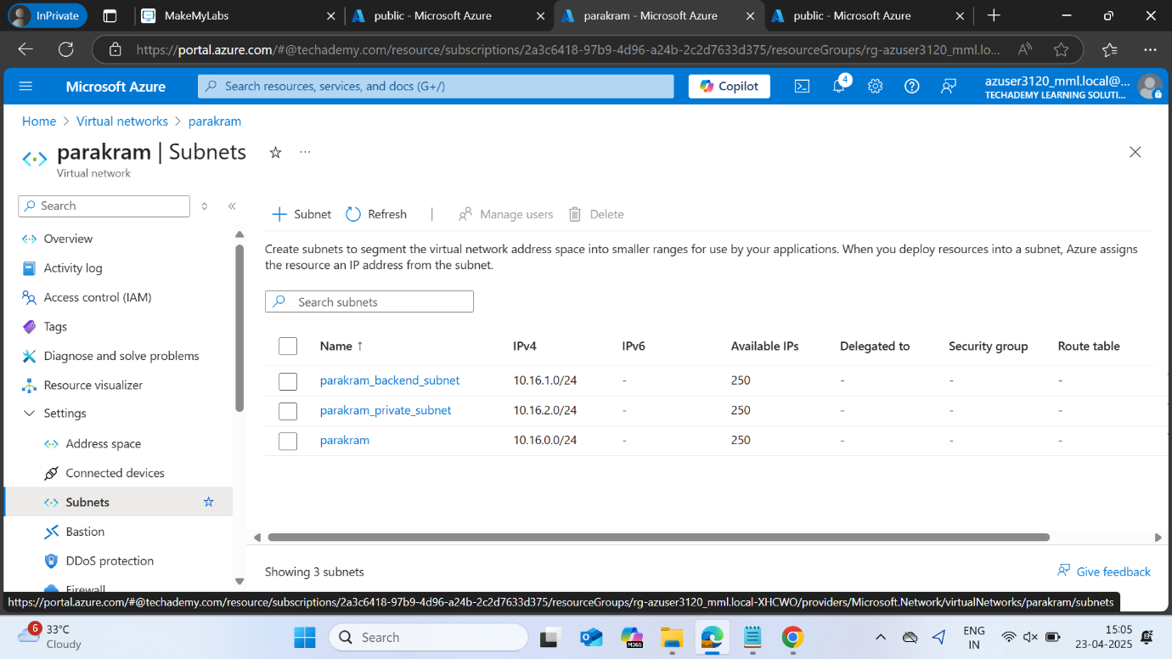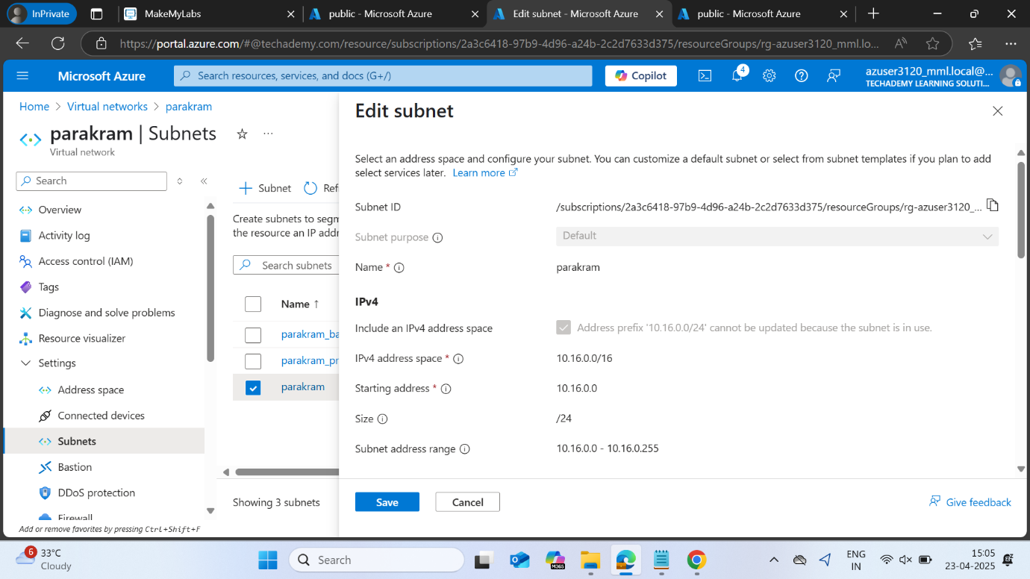

We can configure the subnet to enable private subnet, and specify the NSG while creating the VNET itself, if not specified, Azure will create NSG for each VM separately.

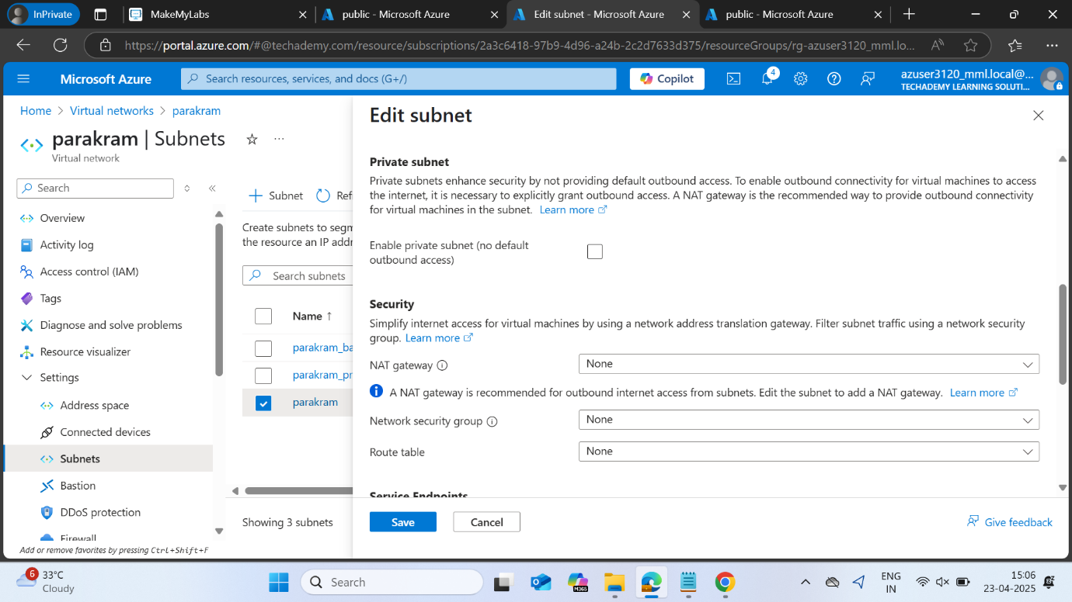

2. Create 3 VM’s for frontend, backend and private

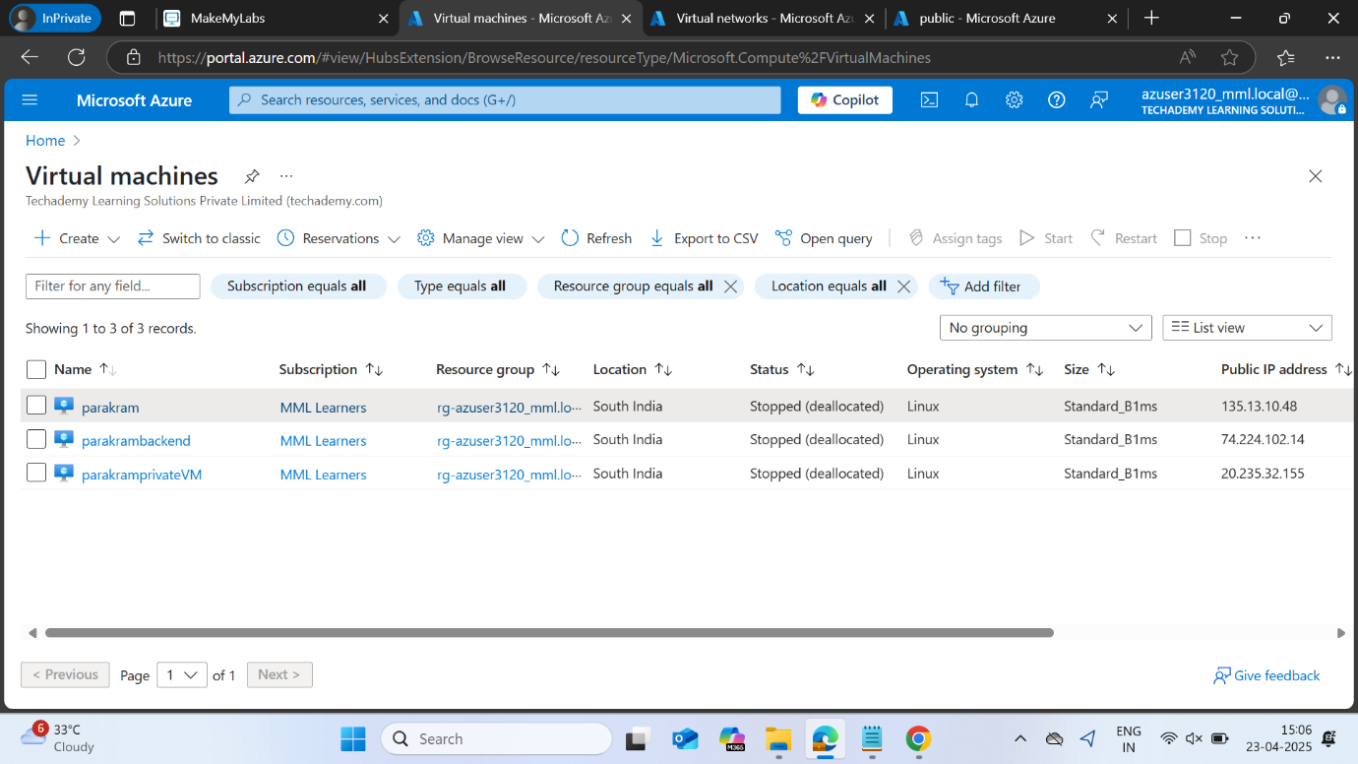

Each of these VM will have their own NSG, which won’t be configured for our purposes.

3. Go to Network Settings -> NSG -> Network Interface -> Dissociate the VM.

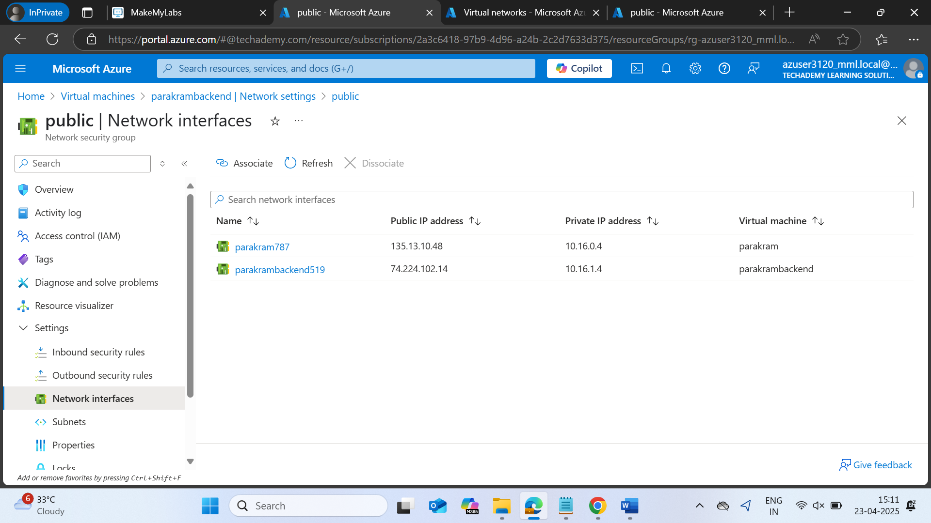

4. Create new NSG -> go to network interface -> associate -> select the VM you want to use

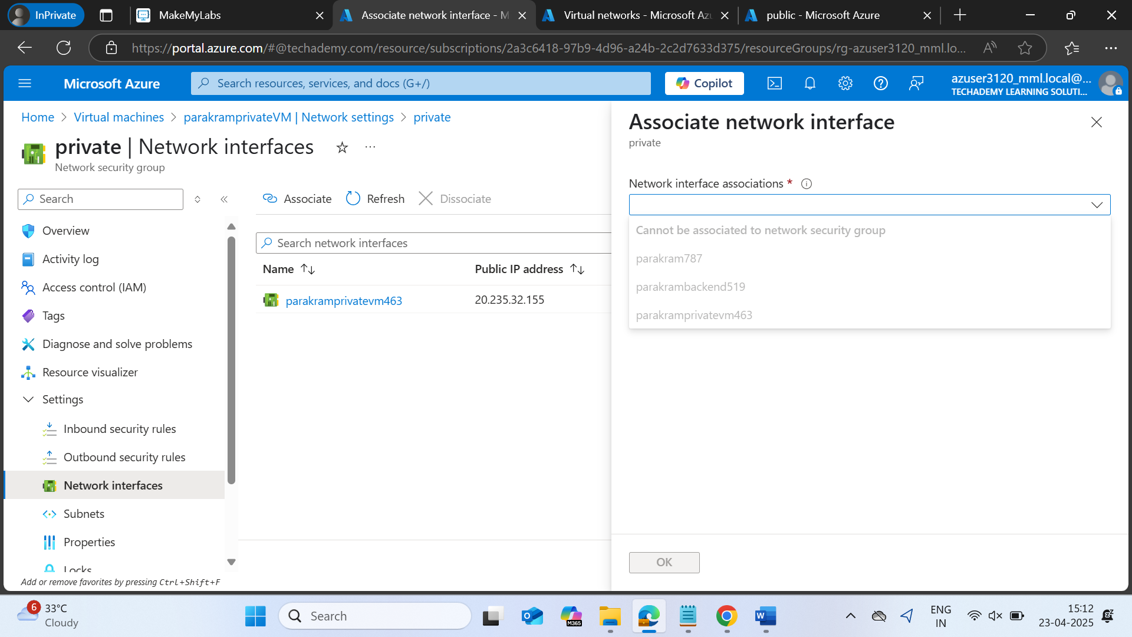

5. You can create, delete and modify inbound and outbound rules for the NSGs

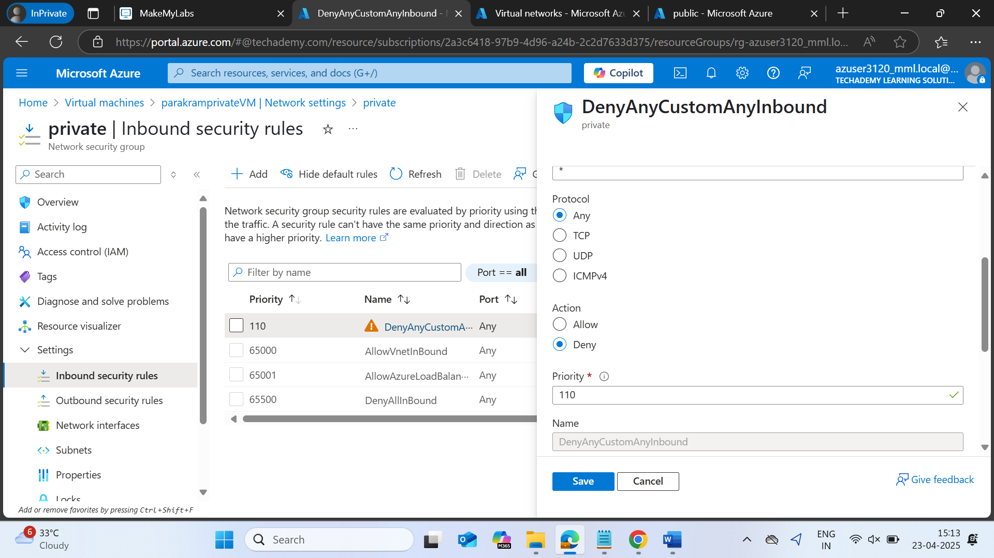

6. Now you should be able to SSH to the frontend and backend from public and SSH into the private. 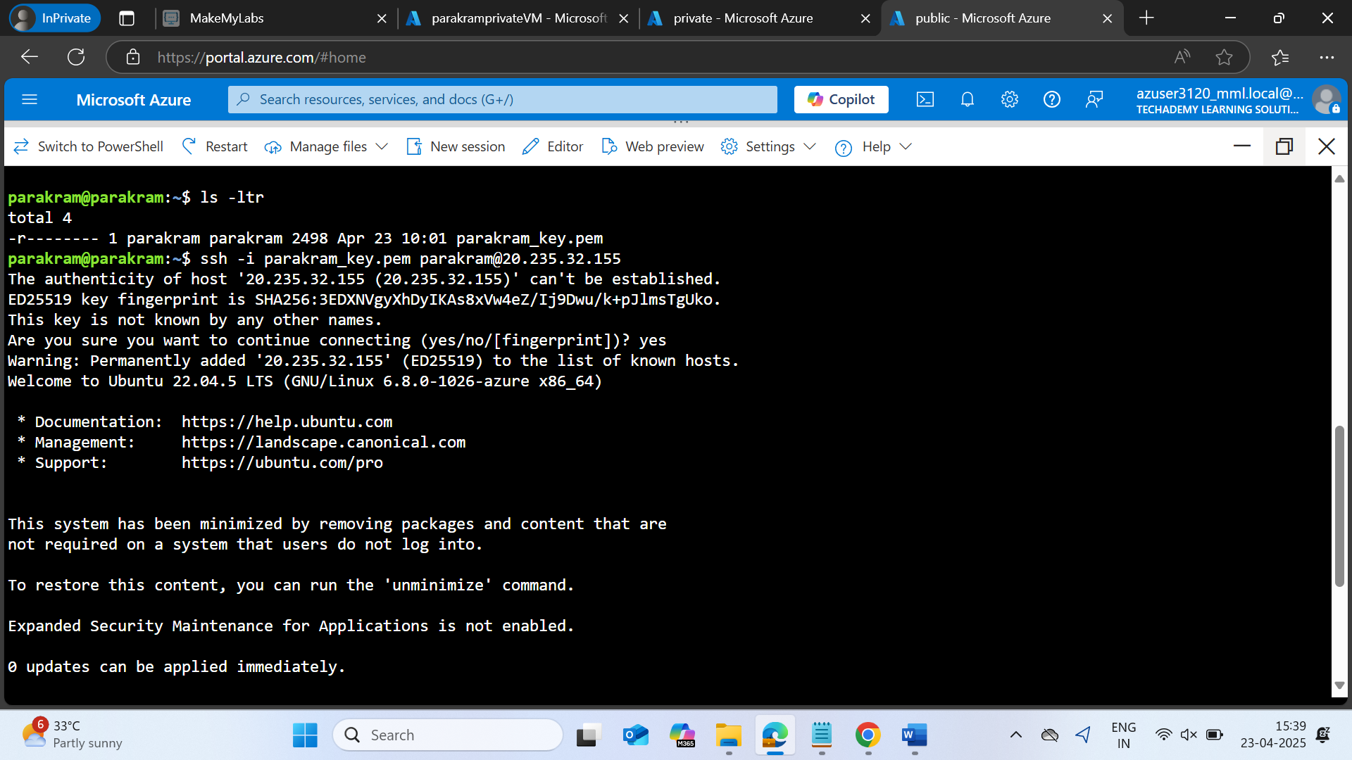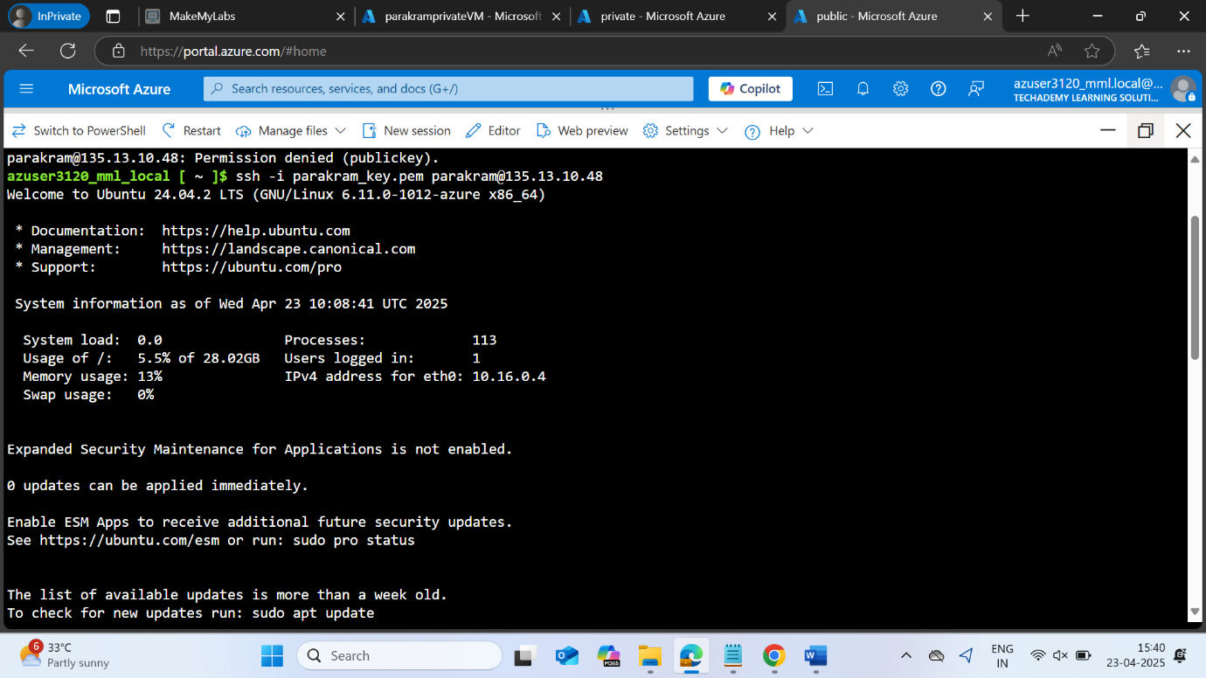

\*\*\* Configuring NSG is important. The VM can be dissociated from the NSG but for association, we need to go to Network Security Groups tab and manually configure it\*\*\*

VNET

subnet(Private)

s subnet(Public)

Private

(Public and Private IP)

Backend

(Only Private IP)

Frontend

(Public and Private IP)